# **Benjamin – Marketing - QA**

## **Quality Assurance**

most of the time quality assurance is treats as the source of good quality in and of itself. that idea turns out to be a unexpectedly imperfect one. after attractive our personal lumps on the subject of quality a few years back, we have a procession on the right way to gaze at it.

* have we done what we promised ?
* have we done something that will make our customers happier?
* have we done something that we will be proud of?

## **Sub Project Plan**

## **Risk Register**

risk management is the systematic process of planning for, identifying, analyzing responding to, and monitoring project risks. it involves processes, tools, and techniques that will help the project manager maximize the probability if a predictable outcome.

in Risk management process we have six major processes and I will explain each of them,

such as plan risk management, identify risk, perform qualitative risk analysis, perform quantitative risk analysis, plan risk responses, monitor and control risks.

plan risk management: this involves how to approach, plan, and execute the risk management activities for a project. the main output of this process is risk management plan.

identify risk: it involves determining the risks that are likely to affect a project and documenting the characteristics of each. the main output of this process is risk register

# Risk Breakdown structure

risk breakdown structure development is a powerful exercise for reviewing areas of concern and identifying potential relationships among these areas. The risk breakdown structure may be developed either from the top down or form the bottom up, much like the work breakdown structure. in a top-down development process, the key is to have an acute awareness o the primary categories of risk sources that exist within the organisation

## **Requirements**

Our team helps build relationships with both customers and colleagues. Internally, we communicate business news, shout about our success stories and inspire over 150,000 colleagues with our values, vision and goals. Externally, we speak to our customers constantly, enabling us to create targeted TV, online and radio campaigns, appealing in-store events and great sub-brands like Taste the Difference. Because we understand exactly what our customers want, we can find new ways to increase satisfaction, loyalty and sales.

**Marketing Requirements**

* User should be able to view the types of items purchased by a customer.
* User should be able to send recommendations/deals to customers.

## **Software**

The world is changing rapidly. Our vision is for FCEPH’s to have a world-class digital and technology function to ensure that we can deliver great services for our customers whenever and wherever they want to shop with us.

This announcement demonstrates our commitment to that goal, and to attracting the best talent in this ever-developing sector. As Manchester is the UK’s second largest technology hub, it’s a natural step for us to recruit there. It’s a great time to be working in retail. This fast-paced, exciting sector is giving rise to the most innovative practices.

## **Component Integration**

I have created a database system for the staff members and customers where they will be able to choose any fruit they want without going around the shop to look for it and for the staff members its used to help them to find which fruit it items is missing in the stock. 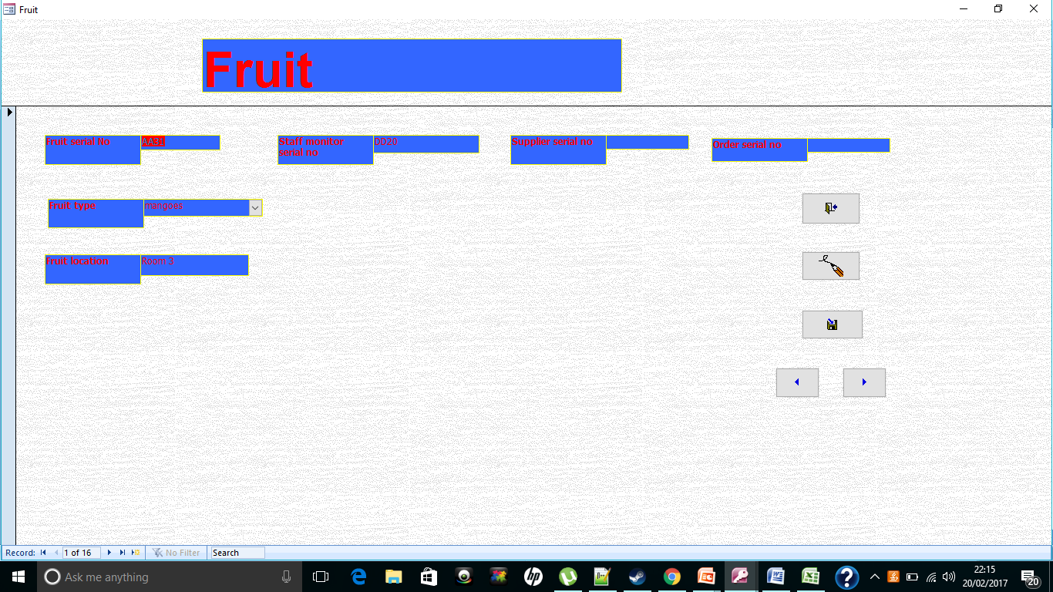

## **Testing**

The market test is generally carried out to ascertain the probable market success in terms of new product’s performance, the level of acceptance of the product, customer satisfaction, and the efficiency of the marketing campaign.